Introducing the Basics
A wonderful dream put into action.

By Haleigh Wesley Oct 25, 2025

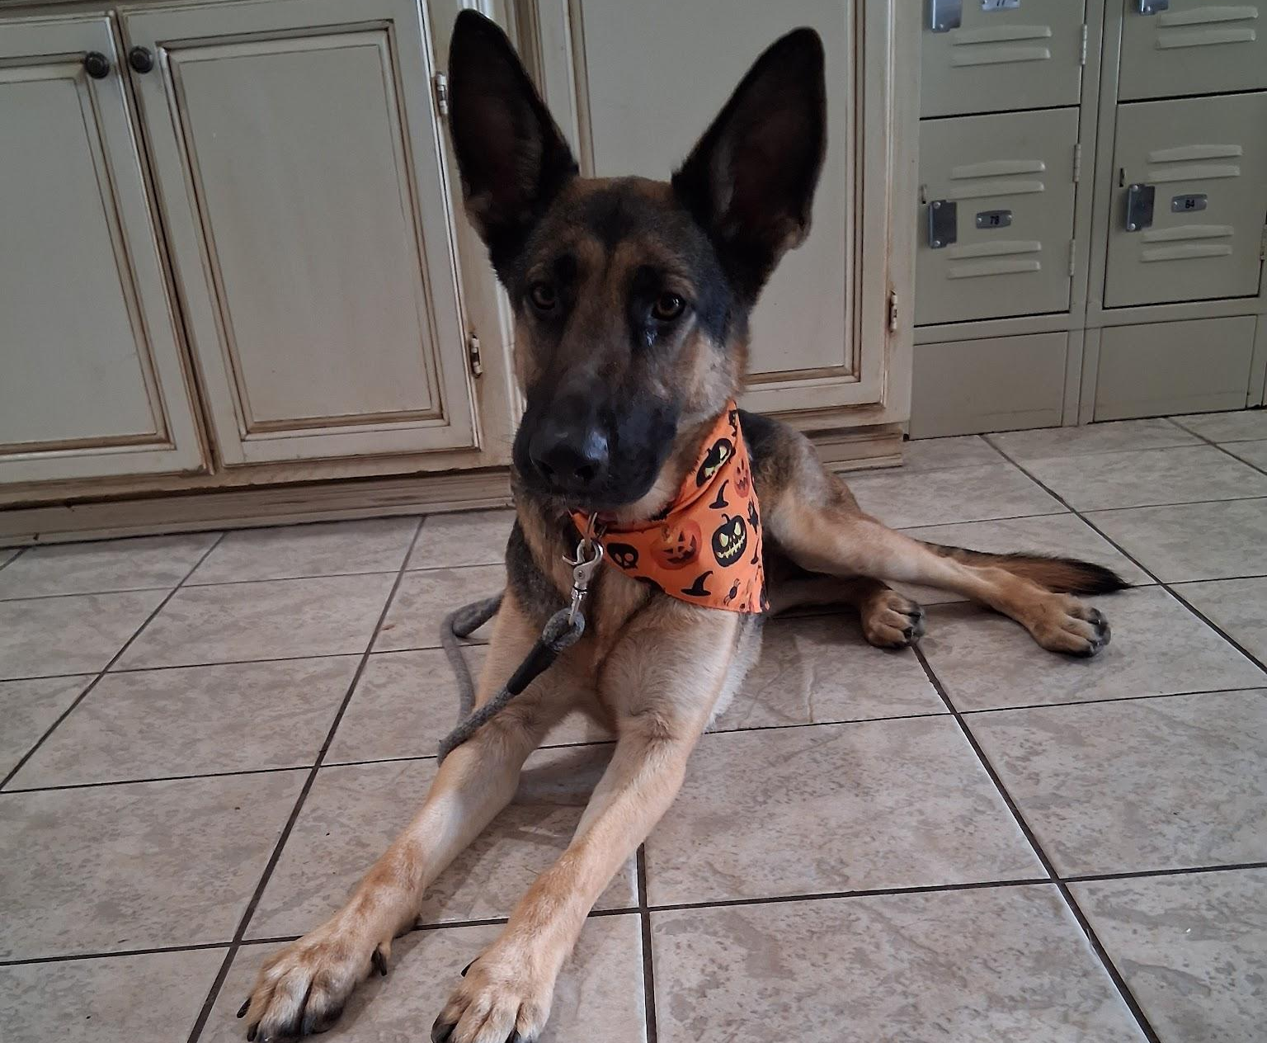
The gallery wall. Photo credit: Haleigh Wesley
Athena Wesley!!

Living Life to the fullest by the Basics!!

Well Athena and I met a little after she was born on April 5th, 2023. She was the center of the pack and still is. Athena and I have been on adventure since. Hello, My name is Haleigh N. Wesley, for blogging I decided to go by Nicolle Wesley. I have been happily married for 3 years to my wonderful husband. Studying to become a dog trainer is and has been the best thing I have ever decided to do. I have taught Athena everything she knows, She still has room for improvement.

We also have a 3 year old, chihuahua/jack russel mix. Who has hardly any training and no socialization either. She was born May 5th, 2022 and She loves to claim her dominance in the family. I have been working with her on basics.

We love to travel, especially with both the dogs. It helps build character and helps us grow closer together as a family. My goal is to tell my story about my knowledge. When it comes to our fur babies and traveling with them. Especially all the tips and tricks you can use with them.

Our Story

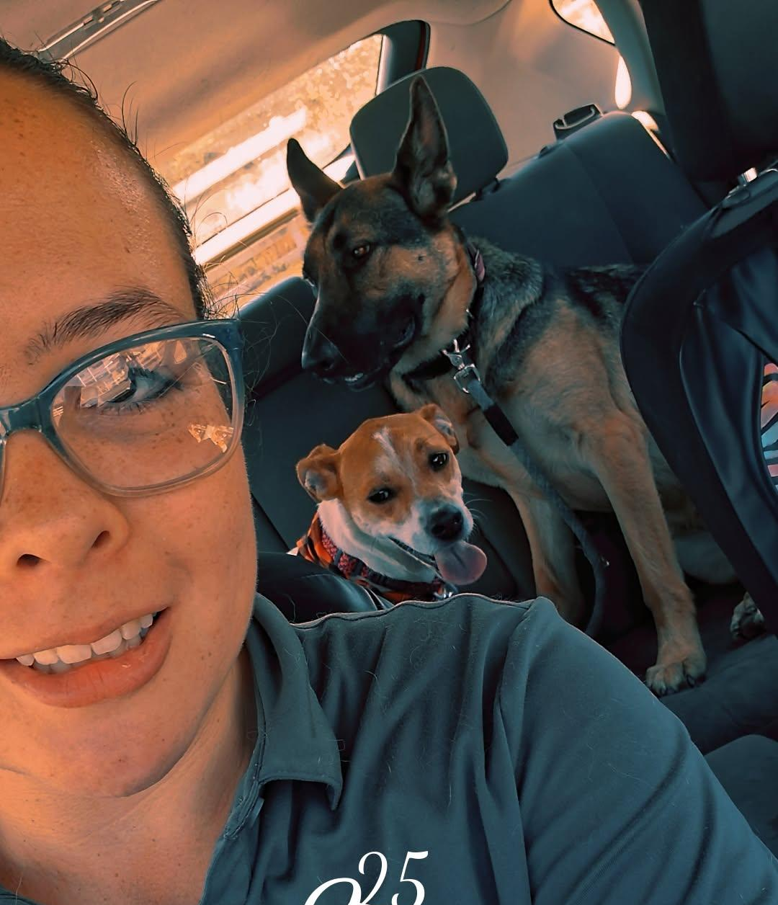 |  | 
It's the Family that makes a Home. |  | Love with Care
It’s good to take a break every once in a while to relax and unwind. We take car rides, go to parks to walk around. I even will go to the park with Athena and work on her basic commands at the park. |  | Our fur babies have feelings, mood swings, they can be sensitive to food and other things in life. Going over basic commands even when they know them, they can build and strengthen your bond.

“Dog training is a gift. A calming,peaceful patience technique. A beautiful bonding creation that will never be broken.”

— Haleigh Wesley,Blogger

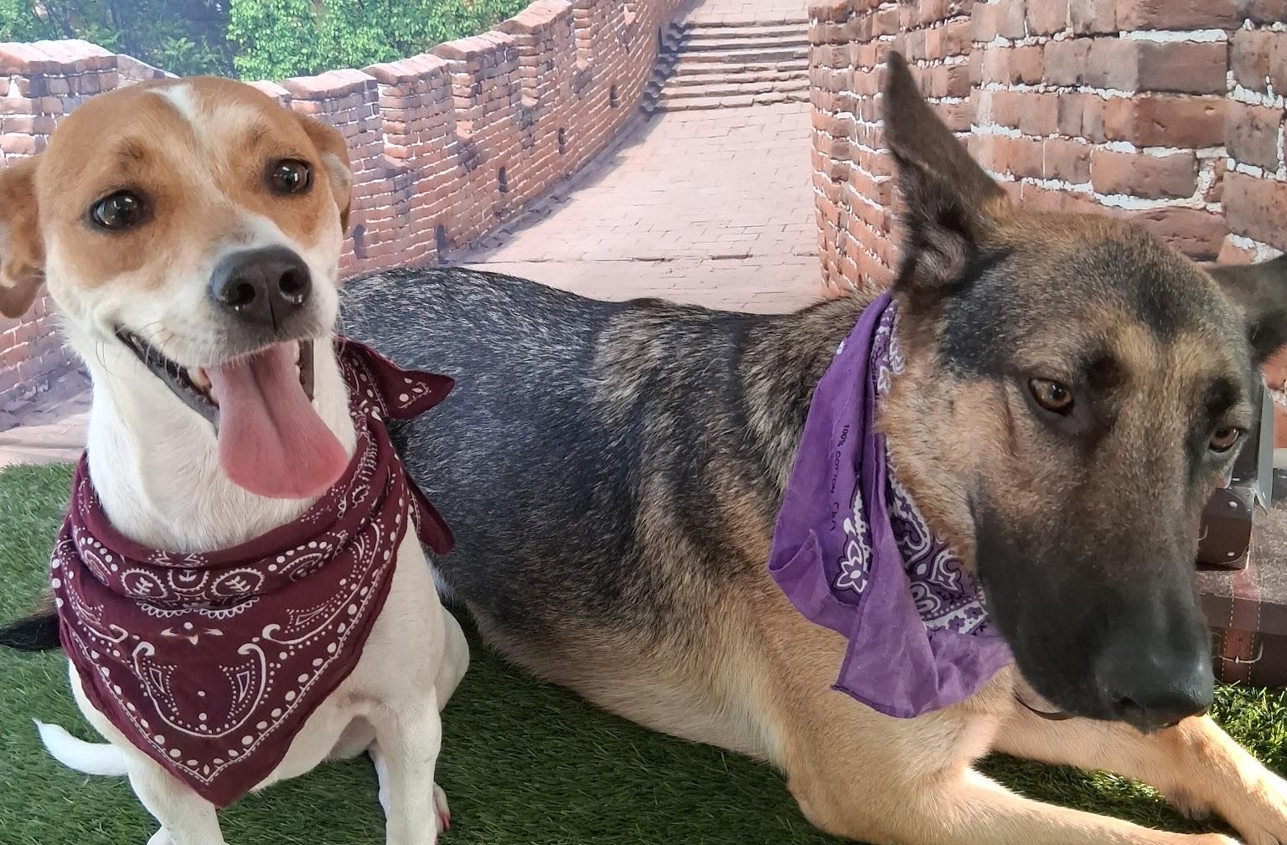
Currently available to read Blogging posts. Photo credit: Haleigh Wesley

The Future We Hold

Being able to show people how to train their dogs ever since I started studying about it. It is amazing, especially helping build and strengthen their bond. Knowing how well you trust your dog and how well your dog trusts you. Knowing how your dog will react in the park will amaze you, but know it will most likely take time.

What to go over:
- The basics of dog commands
- Going over advance commands
- The basics about new parenthood dog owners
- The importance of Socialization
- The importance of grooming your dog
    - Including the food

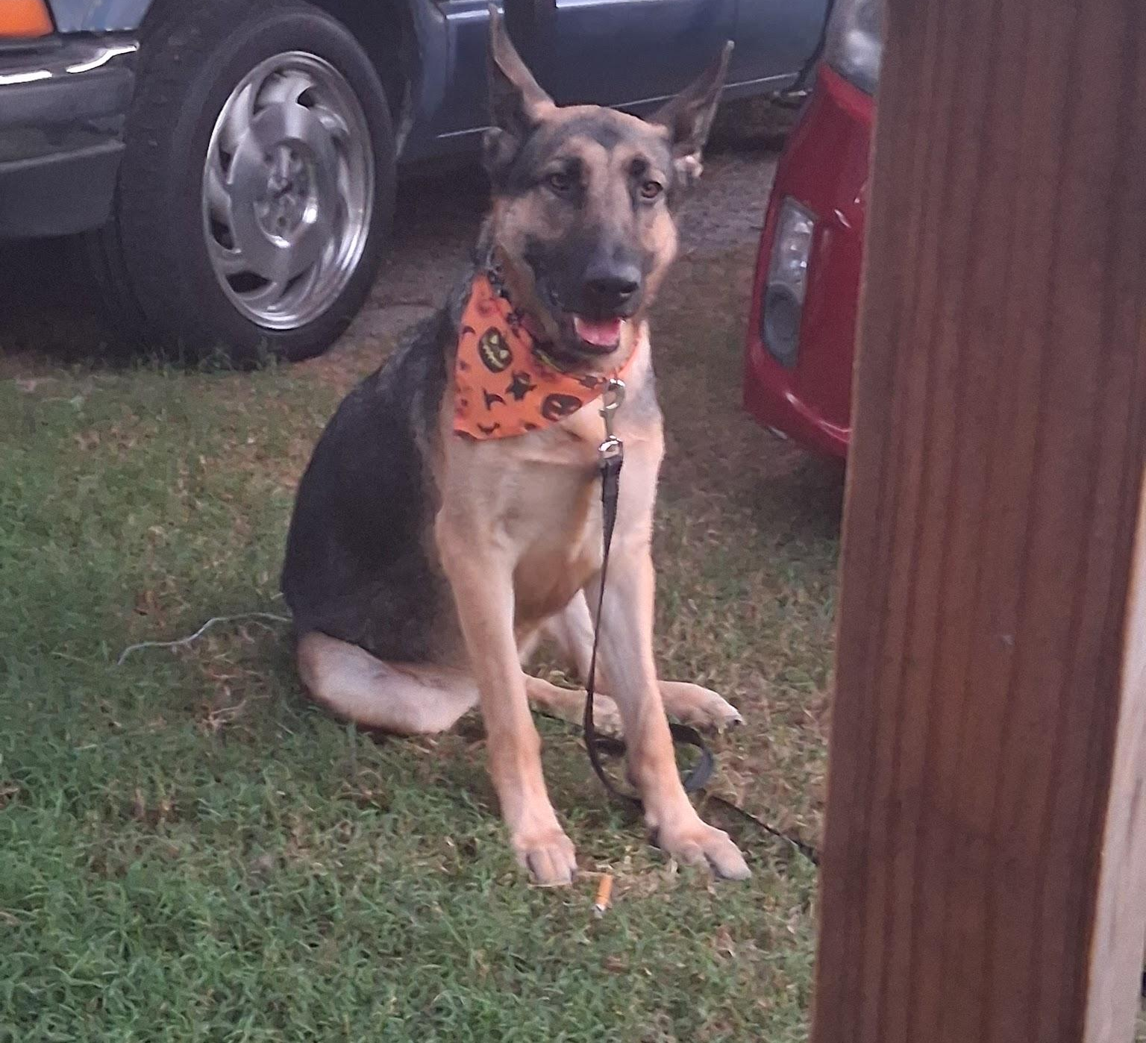
Athena strengthened her stay command. Photo credit: Haleigh Wesley

Bonding Adventure Timing!!

Bonding with your dog, you could start by the simple things. When Athena and I first started building our bond together, we would sit together and I would feed her a handful of food to her. While petting her or brushing her. You can do this at any age with your dog, if it's an older dog it will take time to build a bond with them.

You don’t want to stop the bonding time with your dog. Athena loves it when we have bonding time, it makes her feel more loved and appreciative when we are together as a family and not jealous of the others. I have bonding time with all my dogs one on one. I do different things at different times with them.

Introduction to hand training one on one
Learn the basics of the commands and advanced commands.

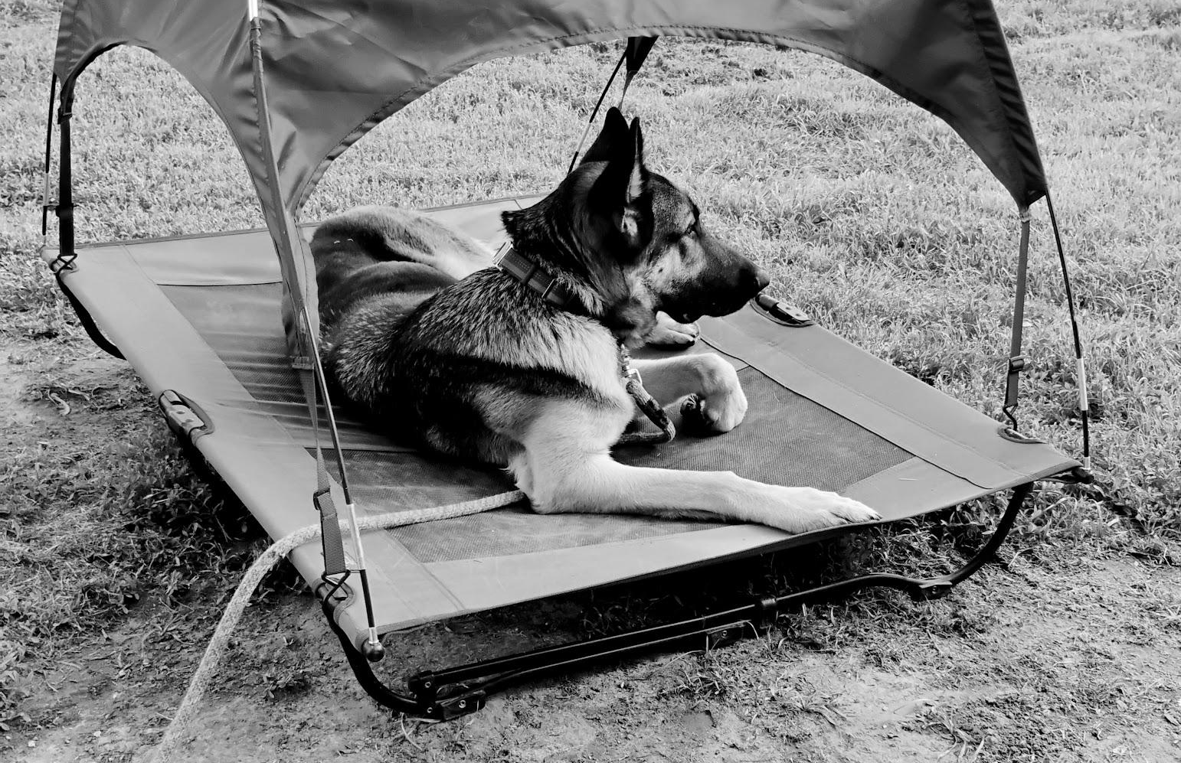
Athena relaxing after her basic commands sessions.

Step by Step Training
Get comfortable with training your dog with confidence.

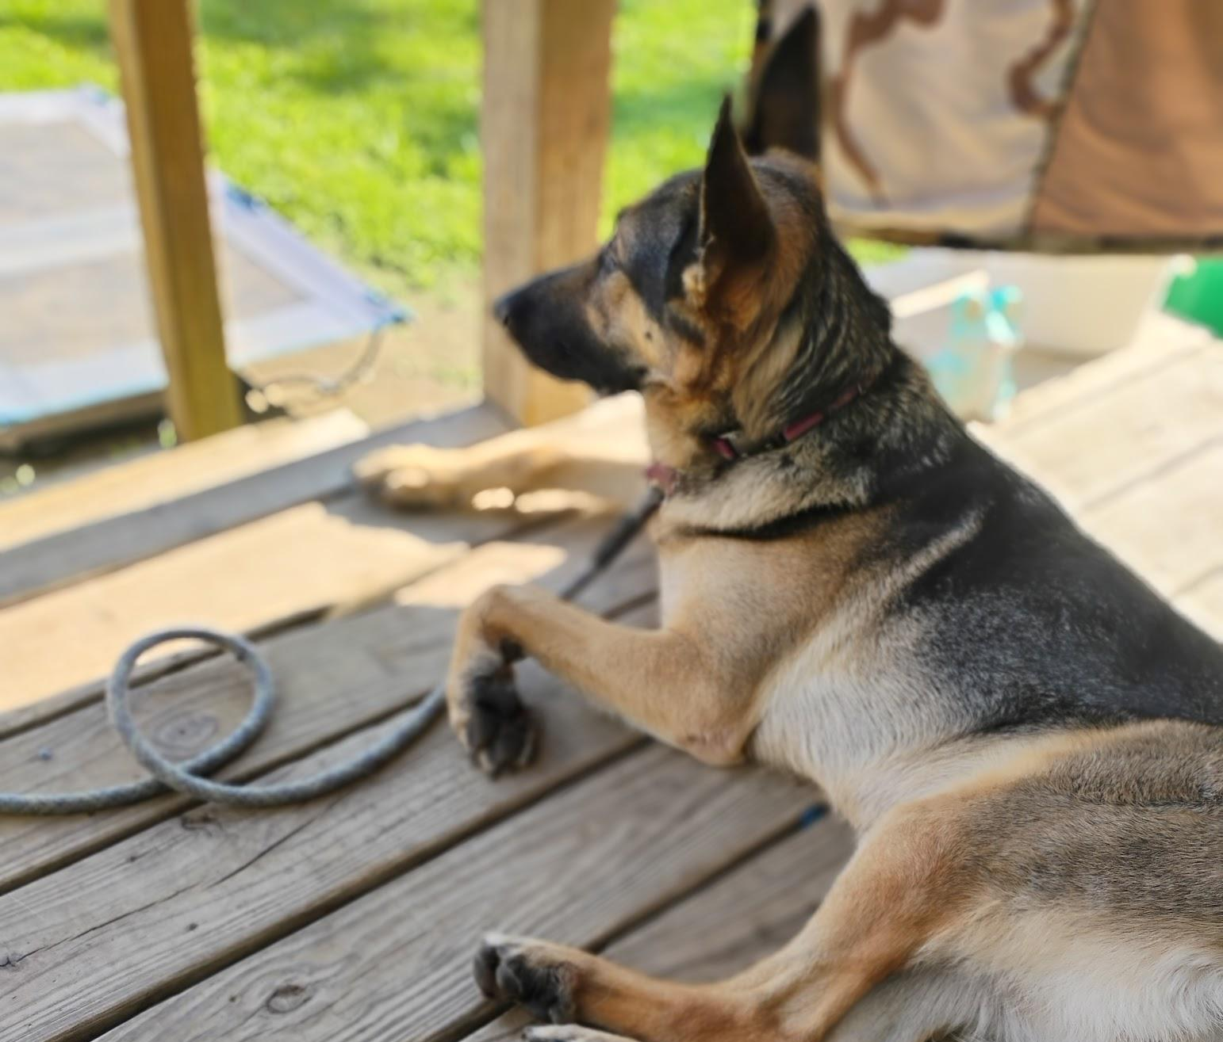

Going Over the Grooming Process
Improving your dog's well-being is also an important process. I read and explore all my options when it comes to the food. When it comes to grooming, that is a process your dog needs training and time with.

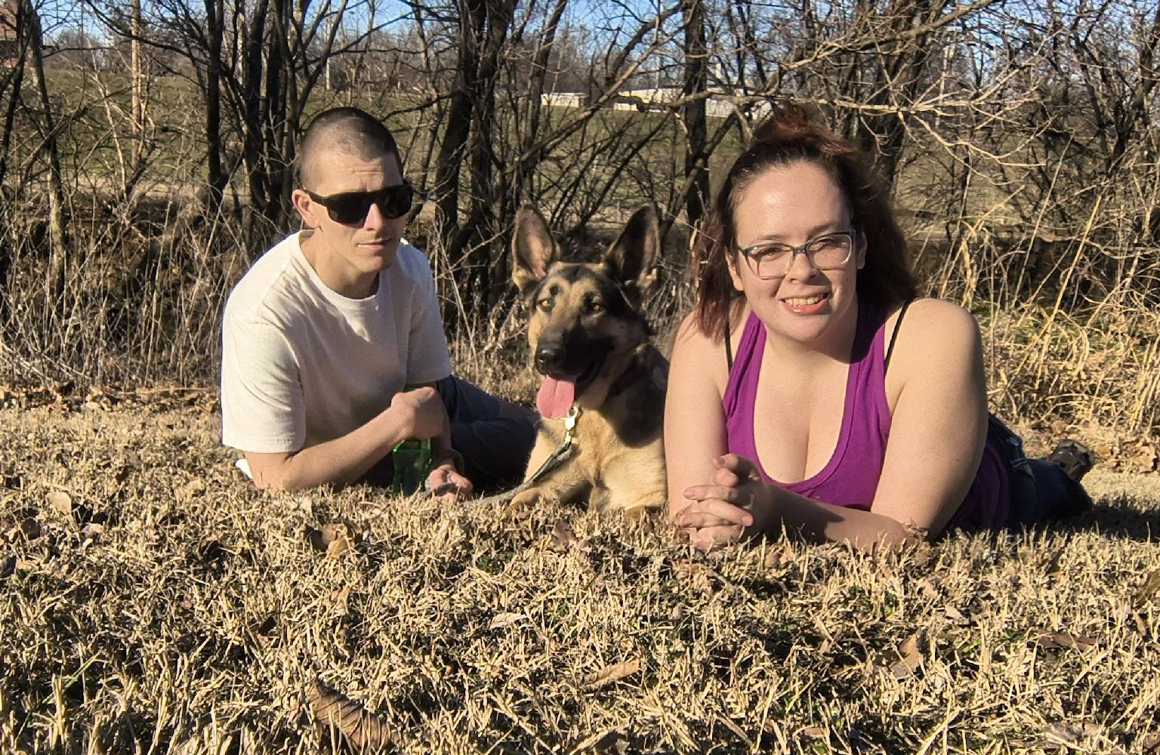

We invite you to join our blog, learning daily about our dogs. Learning how we can adapt better with them and understand them better, while living our day to day lives.

Thank you for being a part of our story. Let's learn something new about our K9’s.

Share & follow

For any inquiries, please contact:

Haleigh Wesley
haleighwesley22@gmail.com
Website
Facebook: Life with Nicolle Wesley

